- One source table Student Table: <40--Fail, >40--Pass, First Division>60
Three Destination Table:
Student_Fail, Student_Pass, Student_FD
Data Flow :
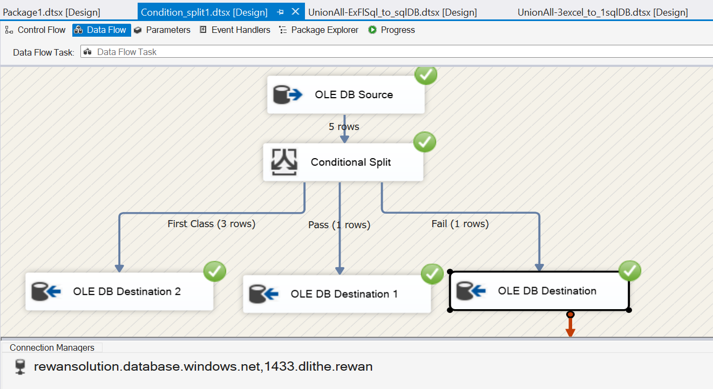
Source:
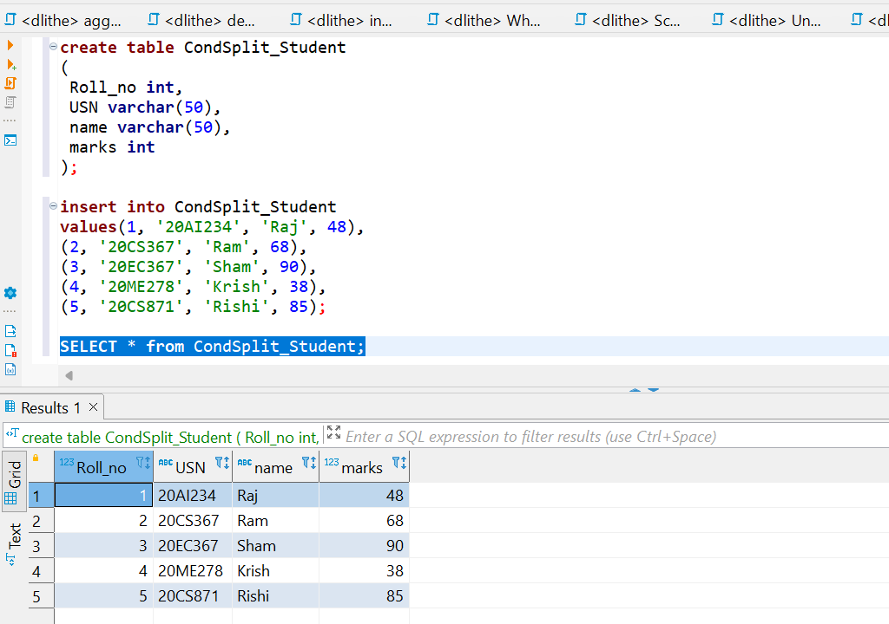

Destination 1: list of Students secured first class
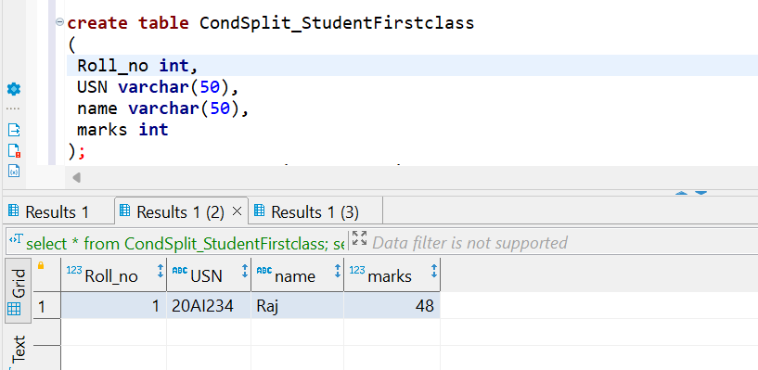
Destination 2: Student Pass
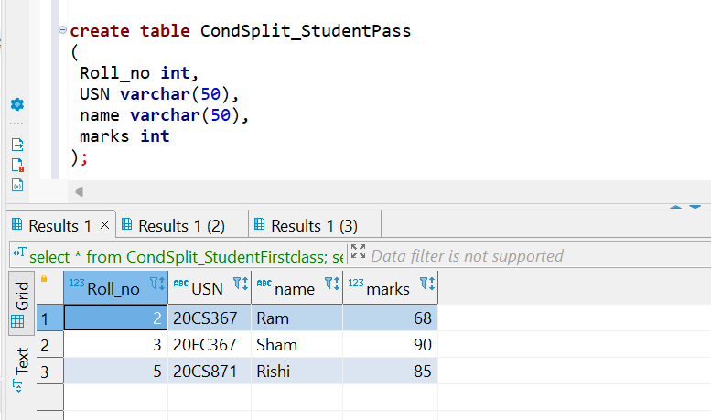
Destination 3: List of failed students
